Title (max. 2 lines)
Given name Surname^{a)}, Given name Surname ^{a),b)}
^{a)} Company / University / Institute, Country, e-mail (only for first or corresponding author)
^{b)} Company / University / Institute (if different from other authors), Country
This is the abstract text. It should be approximately 150-250 words in length. This is the abstract text. It should be approximately 150-250 words in length. This is the abstract text. It should be approximately 150-250 words in length. This is the abstract text. It should be approximately 150-250 words in length. This is the abstract text. It should be approximately 150-250 words in length. This is the abstract text. It should be approximately 150-250 words in length. This is the abstract text. It should be approximately 150-250 words in length.
Keywords: keywords

Introduction
This text gives instructions on the layout of papers for the proceedings of the final conference of COST TU 1403 “Adaptive Facades Network”. The organizing committee kindly requests authors to prepare their papers according to this format. We suggest the authors use this file to write their paper to make sure it meets the layout requirements.
Papers which are not submitted in the proper layout may be returned to the author and/or refused for publication in the proceedings. Papers should be submitted to final.conference@tu1403.eu both in .doc and .pdf format with the mentioning of your PAPER-ID no later than May 21st, 2018.
Please name your files as follows:
- PAPER-ID_paperTU1403.doc(x)
- and PAPER-ID_paperTU1403.pdf

thereby using the PAPER-ID given in the abstract review notification email.

Margins
The proceedings will be published in a digital and printed format. To maintain uniformity, the margins in the submitted file should not be adjusted.

Paper length
The entire paper should be written in English and approximately 3000-4000 words in length. Please do not exceed the maximum number of words.

Font
The paper is to be written in the font Times New Roman, 10 pt, spacing 11 pt after, justified text, single lines.

Units
Only SI-units should be used. Imperial units such as inches, pounds, etc. should not be used.

Paper Opening

Title
The text should be in font Times New Roman. Use the format ‘COST_title’ (20 pt, spacing 24 pt before and 16 pt after, centered text). Use capitals for each main word of the title.

Author
Do not use a blank line between the paper title and the author names. For the author names, the format ‘COST_author’ should be used. The authors names should appear in font Times New Roman, centered in font size 10. The authors should appear with given name followed by surname, e.g. ‘John Doe’.

Affiliation
Do not use a blank line between the author names and the affiliation. Use format ‘COST_affiliation’. The affiliation should appear in Times New Roman, centered and italic in font size 10. Adding an e-mail address or URL is optional. Only add the first (or corresponding) author’s email address.

Abstract
The abstract should be a very concise summary of the paper and contain approximately 150-250 words, depending on the total size of the paper. Do not use a blank line between the last affiliation and the abstract. Use format ‘COST_abstract’. The abstract should appear in Times New Roman, justified in font size 8, spacing before 24 pt;. The left and right margins are 1.5 cm smaller than those of the main text.

Keywords
Finally, some keywords should be provided. Do not use a blank line between the abstract and the keywords. Use format ‘COST_keywords’. The keywords should appear in Times New Roman, justified in font size 8, spacing before and after are 12 pt. The left and right margins should be identical to those of the abstract. Start the keywords with ‘Keywords:’ (bold). The keywords themselves should not be bold.

Header and Footer
The header has a standard text on the opening page of the paper, as well as on the even pages. On the odd pages, please enter the paper title in the header, using format ‘COST_header’ (Times new roman, centered, italics, font size 8).
Do not use footer.

Body Text, Paragraphs, Headings, Lists, Acknowledgements, Citations and References

Body Text and Paragraphs
The body text should be written in Times New Roman, 10 pt, spacing 11 pt after, justified text, single lines. Do not use blank lines between headings and the body text.

Headings
Use format ‘COST_heading1’ for the main headings. They should appear numbered and bold in font size 10. For subsequent headings, use format ‘COST_heading 2’. They should appear numbered and italic in font size 10. Do not use further subheadings, like ‘4.3.1. Heading 3’ or ‘3.2.1.5. Heading 4’.

Lists
To avoid confusion with the headings, it is preferable to use non-numbered lists. Use format ‘COST_list’. The list should appear in font size 10, as follows:
Item 1
- Item 2
- Item 3

Use a blank line beneath a list. If it is absolutely necessary to label the listed items for reference in the subsequent text, the format ‘COST_listalph’ can be used as follows:
Item 1
Item 2
- Item 3

Bulleted lists, however, are preferred.

Acknowledgements
Acknowledgements can be added at the end of the paper, before the references.

Citations
Cite references in the text by name and year in parentheses. Some examples:
- Negotiation research spans many disciplines (Thompson 1990).
- This result was later contradicted by Becker and Seligman (1996).
- This effect has been widely studied (Abbott 1991; Barakat et al. 1995; Kelso and Smith 1998; Medvec et al. 1999).

References
For the list of references the format ‘COST_reference’ should be used. The text should appear in font 8. The list of references should only include works that are cited in the text and that have been published or accepted for publication. Personal communications and unpublished works should only be mentioned in the text. Do not use footnotes or endnotes as a substitute for a reference list.
Reference list entries should be alphabetized by the last names of the first author of each work. Some examples:
- Journal article:
Hamburger, C.: Quasimonotonicity, regularity and duality for nonlinear systems of partial differential equations. Ann. Mat. Pura Appl. 169, 321–354 (1995)
- Article by DOI:
Sajti, C.L., Georgio, S., Khodorkovsky, V., Marine, W.: New nanohybrid materials for biophotonics. Appl. Phys. A (2007). doi:10.1007/s00339-007-4137-z
- Book:
Geddes, K.O., Czapor, S.R., Labahn, G.: Algorithms for Computer Algebra. Kluwer, Boston (1992)
- Book chapter:
Broy, M.: Software engineering — from auxiliary to key technologies. In: Broy, M., Denert, E. (eds.) Software Pioneers, pp. 10–13. Springer, Heidelberg (2002)
- Online document:
Cartwright, J.: Big stars have weather too. IOP Publishing PhysicsWeb. http://physicsweb.org/articles/news/11/6/16/1 (2007). Accessed 26 June 2007

Always use the standard abbreviation of a journal’s name according to the ISSN List of Title Word Abbreviations, see ISSN.org LTWA. If you are unsure, please use the full journal title.

Figures, Tables and Equations

Figures
Figures should be embedded in the word document. Do not supply us with separate pictures. Use figures in the highest resolution available. To obtain satisfying results, at least 300 dpi should be used for pictures (with lettering 500 dpi). Colour figures can be included, but must be fully readable for a printing version in black & white.
To avoid figures going wandering through the word document, they should be placed in a table, with no visible borders. For the format of figures, select the format ‘COST_figure table” and insert a table with 1 to 3 columns and 2 rows. Center all inserted figures in row 1. Use row 2 for the figure headings. Use one of the alternatives provided below to place figures. Text appearing in figures such as graphs should be in Times New Roman, font size 8.
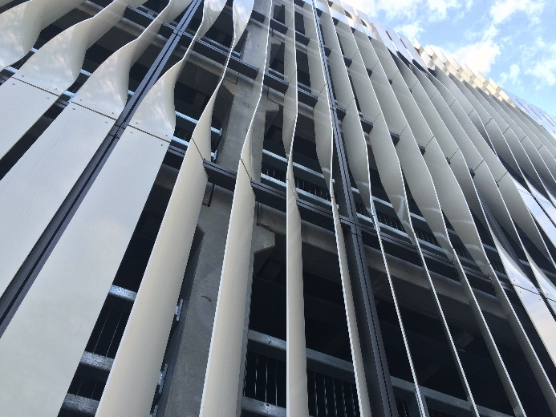
Fig. 1 Façade example, Malmö in 2014 (please replace).
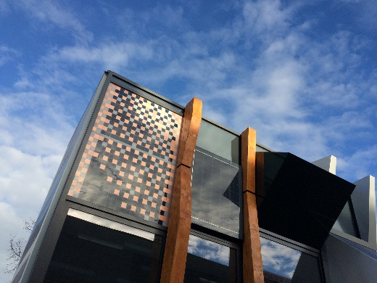  a) | 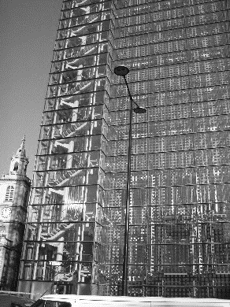  b) | 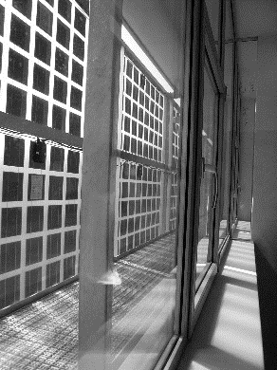  c)
Fig. 2a), b) and c) Some pictures of PV facades (please replace).
Here the body text continues.

Tables
Select the font format ‘COST_table grid’ and insert a table with the appropriate number of columns and rows. A table should always have the full page width. In printing, only the horizontal lines should be used at the very top and bottom of the table, and below the column headings. No vertical lines shall be visible. Cells may be split or joined by the author, if required. For the text in the table, use the font format Times New Roman, 8 pt, aligned to the left side of each column. Each table should have a brief and self-explanatory title. A table should have a heading above it. Use the format ‘COST_table’ for the heading.
Table 1: An example of required table layout.
Example | Type | Actuator | Response time
1 | Material | chemical | seconds, minutes
2 | Material | thermal | seconds, minutes
3 | Component | mechanical | minutes
4 | Facade | mechanical | hours

Here the body text continues.

Equations
Use the font format ‘COST_equation’ and the word equation editor for equations. Number equations in parenthesis flush with the right margin. Do not use blank lines between the text and the equations. Example:
(1)
Here the body text continues.

Acknowledgements
Acknowledgements can be added at the end of the paper, before the references.
A last advice: Authors whose native language is not English are advised to seek a proof-read of a native English speaker before submitting their manuscripts.

References
Aldawoud, A. (2013). Conventional fixed shading devices in comparison to an electrochromic glazing system in hot, dry climate. Energy and Buildings, 59, 104-110.
Fiorito, F., Sauchelli, M., Arroyo, D., Pesenti, M., Imperadori, M., Masera, G., & Ranzi, G. (2016). Shape morphing solar shadings: A review. Renewable and Sustainable Energy Reviews, 55, 863-884.

